How to Add a Carrier From NAV
This document will help guide users to adding a new carrier into the TMS system.
1) Go to Departments in NAV and find Transportation, Setup, Dynamics TMS Vendor Carriers.
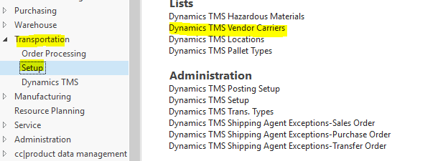
2) Click on New in the action’s menu and search for the carrier you want to send to TMS. Be sure to tab through and click ok when done. Click Refresh and you should see the check box marked. Indicating this is now synchronized and sent to TMS for further set up. There may be a processing delay of a few seconds.
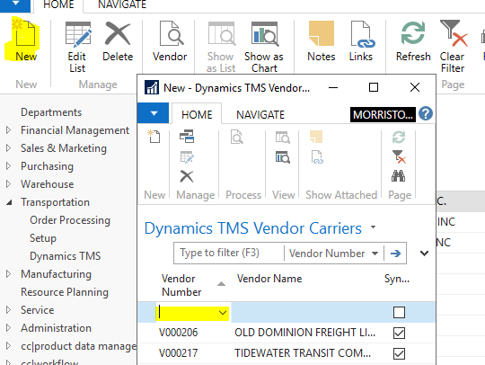
3) Then login into DTMS and go to the Carrier Page for the specific Legal Entity you want to assign this carrier to. Use Change Legal Entity to load new carrier for different Legal Entity.
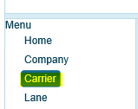
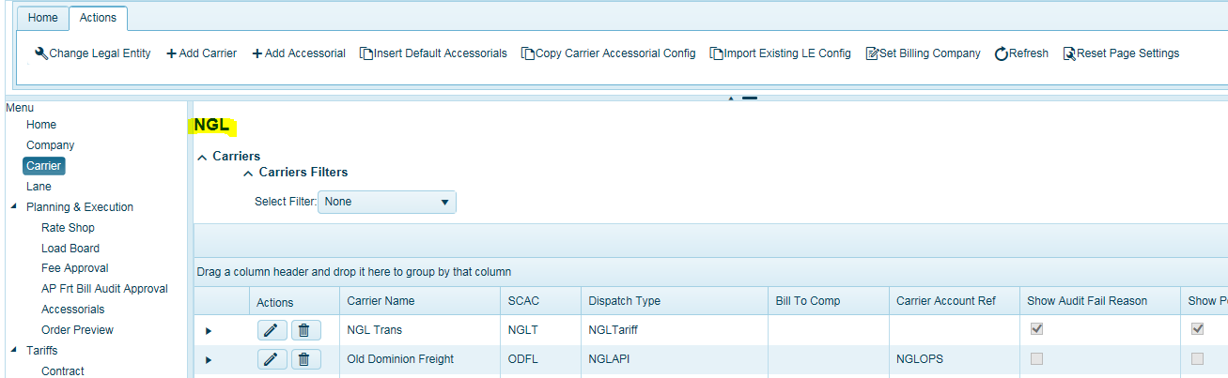
4) In the Actions menu, Click on Add New Carrier and using the drop-down list find the new carrier to add.
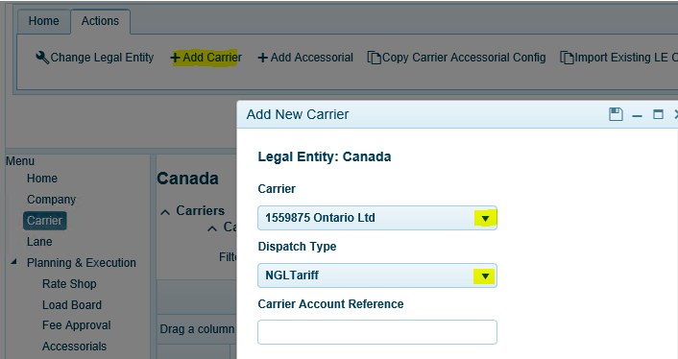
5) Insert SCAC and Select the Dispatch Type for each carrier.
If using TMS tariff system, select NGL Tariff.
If using API’s, contact NGL for set up and Account Reference information and further API configuration. Users can always reference a carrier that is already using API’s to obtain this information.
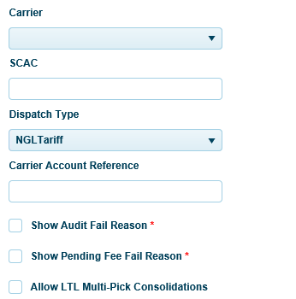
Carrier Account Reference = Is used for API’s only, leave blank otherwise. See support for the correct reference account.
Show Audit Fail Reason = If carrier is set up to use Web Settlement, it will display Failed if invoice failed audit.
Show Pending Fee Fail = If carrier is set up to use Web Settlement, it will display Pending waiting on approval.
Allow LTL Multi Pick Consolidations = If new carrier will be making multi location pick-ups for LTL consolidation, check Allow LTL Multi-Pick Consolidations. The system will calculate freight costs based on the aggregated weight from each location, shipping to the same delivery location. Additional set up in the Parameters is required. See support for assistance.

6) Choose configuration for Expired Load Tenders and insert email address.
Expired Loads = Check this box to use the Legal Entity default (See Legal Entity setup). Or leave blank for carrier specific.
Insert the TMS distribution email address created for the logistics team. Any expired loads will be sent to this distribution list.
Expired Loads Email To = Email address used to receive expired load tenders. Best to use group TMS email address.
Expired Loads Cc = Carbon copy Email address used to receive expired load tenders.
is used for tendering and the time settings used as to when a load tender should expire. There are two settings. 1) Legal Entity (default) 2) By carrier.

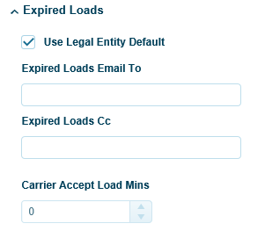
Then insert the amount of time in minutes you allow for carriers to accept/reject a load tender. If Legal Entity default is checked, it will use setting in the Legal Entity Maintenance screen.
Carrier Accept Load Mins = The amount of time in minutes carriers have to accept a load tender. This can be set at the Legal Entity level or carrier specific level. If Legal Entity is checked, the system will use the Legal Entity default setting. Note, this does not impact API carriers.
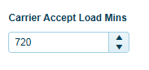

7) Once you have added the carrier, click in the row of the carrier you just entered so it’s highlighted, and in the Ribbon Bar, click on Set Billing Company. Note, this only pertains to those using the web client for load planning.
Set Billing Company allows to you assign the company/location where all freight bills or related information should be sent i.e. Bill To. Click and highlight a carrier so it turns Blue, Select Set Billing Company in the Actions menu and select the company/location.

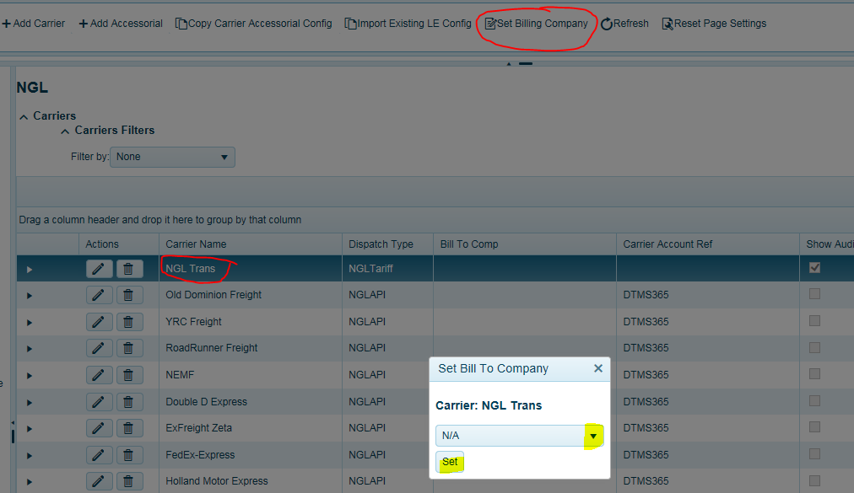
8) Then go to the desktop client and click on Carrier Maintenance tab and select the carrier you just entered.
Make sure the Active box is checked.
Make sure NEXTrack Portal is checked.
Insert contact name, phone, and email address. Check the default contact box if tenders are to default to this contact. Only one default can be selected.
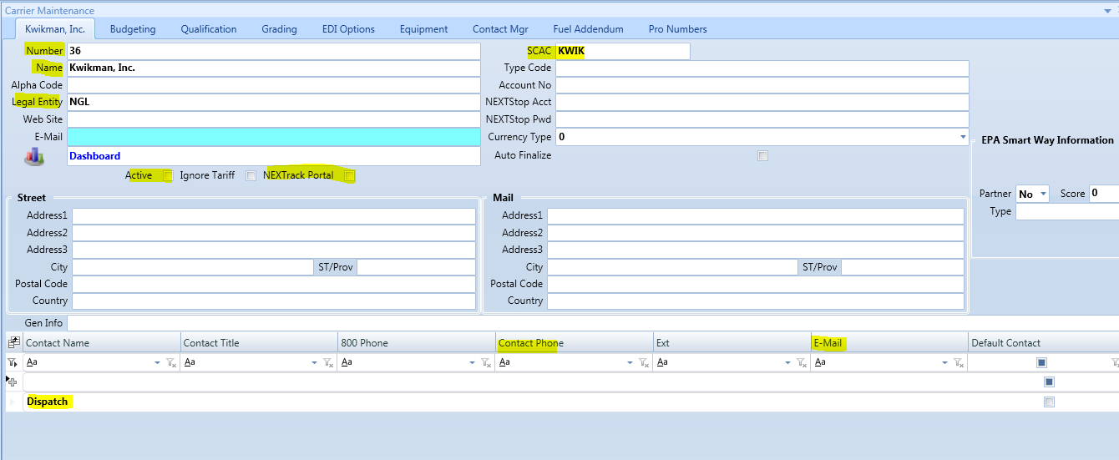

9) Enter in Carrier Qualifications
a) carrier’s insurance expiration date.
b) Insert carrier’s cargo liability insurance value per shipment (typically $100,000)
c) Insert exposure for all open shipments by carrier ($1,000,000 estimated)
Current exposure (auto populated) is running total of open loads with this carrier based on product value.
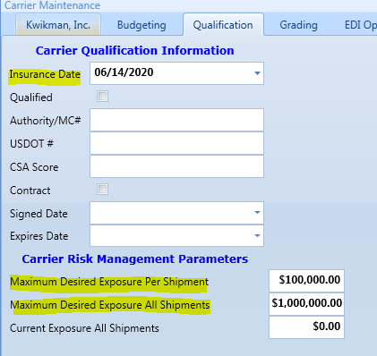

You have completed the carrier set up.
Now enter in carrier tariffs, fuel, fees, and provide any carrier user access if required.
See below to configure carrier accessorial tolerances for freight bill audit in the Carrier Page.

How to Configure Carrier Accessorial Fee Audit Setup
Once you have completed the carrier set up, you will now want to complete the carrier fees set up to enable carriers to enter their fee(s) and invoices in the portal or EDI 210’s depending on your TMS configuration. If you’re entering freight invoices manually and using the Quick Edit entry, then you do not have to complete this step.
1) Go to the Carrier Page click on the Actions Tab.
2) Click on Carrier Name so it turns blue.
3) Click Add Accessorials.
This is where you will set up all fees unique to this carrier and fees you expect them to enter into the system when entering invoices or for receiving fees via EDI 210’s. Each configuration can contain a variety of fee(s). User should apply all fees possible for each carrier. Most common will be fees such as:
• Unloading • Detention (Origin) • Detention (Destination)
• Tarp fee • Re-delivery • Stop charges
• Misc (this is a for any fee that may not be configured but allows entry by carrier)
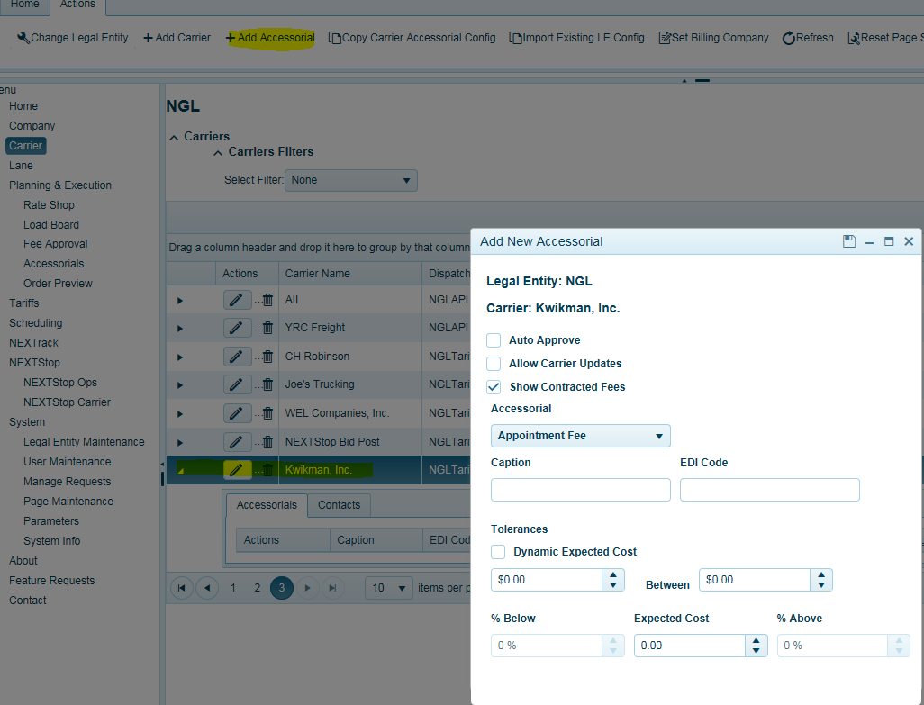
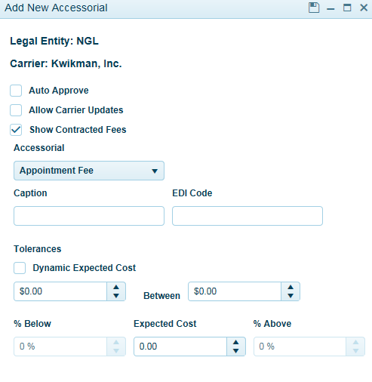
For each fee you apply, you must select the workflow configuration you desire by checking the boxes and click save when done.
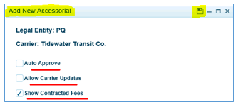

Auto Approve = If fee is within tolerance, it will bypass manual/tms user approval if checked on. If not checked, users will have to approve this fee each time to pass audit.
Allow Carrier Updates = Allows carriers to edit a pre-determined fee when entering an invoice if checked on. Recommended to be checked.
Show Contracted Fees = Precalculated fees as part of the carrier’s tariff and will display in the Carrier invoice entry screen if checked on. If not checked, carriers will not see fee and will not be able to change/update fee. Recommended to be checked.
Select your fee from the drop-down list. These fees are loaded from the TMS Accessorials table in the Load Planning page. It is important to configure and make available all fees to carriers you expect them to enter or when EDI is being used. If a fee does not appear here, the web settlement carrier will not see the fee and it must be set up in order for carrier to insert fee. Web Settlement Carriers should contact TMS users to set up fee if missing. When receiving 210 EDI invoices, any missing fee will go to the approval screen with a notification. User should configure this fee for this carrier for the next time in Carrier page.
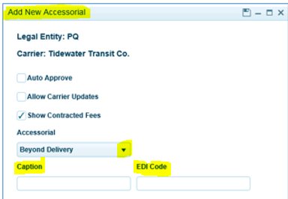
Once your fee is selected from the drop-down list, the Caption field and EDI Code (if set up) will auto populate. Users should not modify EDI Code field unless they feel and have confirmed it is incorrect per carrier EDI Set up.

How to Configure Carrier Fee Tolerance Set Up
The next step would be to apply your tolerance ranges. There are three different settings. First is a flat dollar low and high range. Second, you can apply a percentage low and high range against a known value. Third, is Dynamic Expected Cost. If no known value is entered, the percentage low and high ranges will compare against the fee entry.
- Each Fee for each Carrier has individual settings assigned to each Legal Entity.
  - Flat Rate Low Value: minimum dollar value allowed; typically, zero.
  - Flat Rate High Value: maximum dollar value allowed.
  - Expected Cost: The Expected Cost is only used with the percentage tolerance calculations.
  - Lowest Percentage Factor: based on a pre-determined Expected Cost. The lowest percentage below the Expected Cost that is allowed, typically this is 100%, which will evaluate to a minimum cost of zero dollars.
  - Highest Percentage Factor: base on the Expected Cost, the highest percentage above the Expected Cost that is allowed.
- Calculation Rules:
  - If the Expected Cost is zero, the system will use the Flat Rate values to determine if the Cost falls inside the Flat Rate Tolerances.
  - If the Expected Cost is non-zero, the system will use the Percentage Factors to determine if the Cost falls inside the Percentage Tolerances.
- Flat Rate Formula:
  - If Cost falls below the Flat Rate Low Value the fee cannot be auto-approved.
  - If the Cost exceeds the Flat Rate High Value the fee cannot be auto-approved.

- Low Percentage Factor Formula: If the Cost falls below the Calculated Low Value based on the Low Percentage Factor the fee cannot be auto approved.
  - If Low Percentage Factor is zero, the Calculated Low Value is equal to the Expected Cost; the fee cannot be auto approved if it falls below the Expected Cost.
  - If Low Percentage Factor is greater than zero, we apply the Low Percentage Factor to the Expected Cost: where the Calculated Low Value equals the difference between the Expected Cost and the product of the Expected Cost and the Low Percentage Factor.
  - Example: In this example the Lowest Cost Allowed is $105.00
    - Expected Cost = 150, Low Percentage Factor = 30%.
    - Calculated Low Value = 150 - (150 * 0.30)
    - or $105.00 = $150 - $45.00
- High Percentage Factor Formula: If the Cost exceeds the Calculated High Value based on the High Percentage Factor the fee cannot be auto approved.
  - If the High Percentage Factor equals zero the Calculated High Value is equal to the Expected Cost, the fee cannot be auto approved if it exceeds the Expected Cost.
  - If the High Percentage Factor is greater than zero, we apply the High Percentage Factor to the Expected Cost: where the Calculated High Value equals the sum of the Expected Cost and the product of the Expected Cost and the High Percentage Factor.
  - Example: In this example the Highest Cost Allowed is $195
    - Expected Cost = 150, High Percentage Factor = 30%.
    - Calculated High Value = 150 + (150 * 0.30)
    - or $195.00 = $150 + $45.00
Using Flat Rate example:
Enter in dollar low and high range. Low = $0 High = $195
The fee entered by the carrier must fall between this range.
Percentage values and average value all must be zero and not being applied.
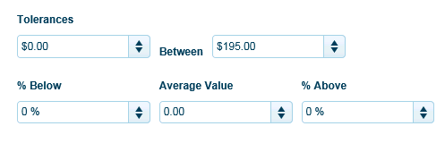

Using Percentage Rate Example:
Dollar value ranges are equal to zero and not being applied.
Percentage values are set to 100% below Expected Cost value ($150) and 30% above (.30 x $150 - $195) Expected Cost Value $150.
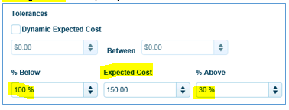
Dynamic Expected Cost
This is used when you want to allow for variability in the fee entry by the carrier. When checked on, you enter in the % Below value (100% to equal zero) and % Above value ranges.
For example: Let’s say you configured fuel to use Dynamic Expected Cost. If your settings were 100% below value and 10% high value and the actual fuel cost for a given load was $225.00. This configuration will allow for $0 on the below value and will allow up to $247.50 (10%) on the high value.
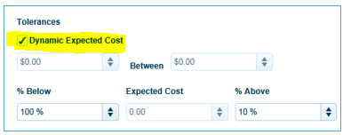
Click on black arrow next to carrier to see all fees set up for this carrier. You can also Edit a fee to make changes or Delete.
